EAT YOGURT, FUNDRAISE, IT PAYS
TICKET – PARK YOGURT

ADMIT ONE
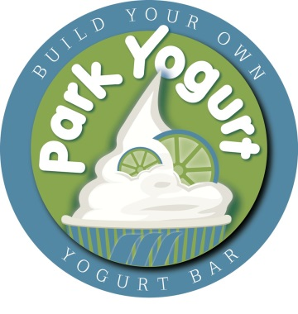
On the day of your event, Park Yogurt will donate 20% of all pre-taxed yogurt/beverage sales from
your guest that presents this fundraising ticket.

We look forward to helping your organization meets it financial goals. Together, we can make a
positive impact and help keep our community working and playing together.

(Present this ticket to Park Yogurt Staff on the date & time listed below)

SAINT LOUIS PARK SPANISH IMMERSION SCHOOL
Feb 27th – March 5th , 2016 * 1:30 PM – 10:00 PM
PARK YOGURT * 6416 W Lake Street * St. Louis Park, MN 55426 * 952-999-0632

EAT YOGURT, FUNDRAISE, IT PAYS
TICKET – PARK YOGURT

ADMIT ONE
On the day of your event, Park Yogurt will donate 20% of all pre-taxed yogurt/beverage sales from
your guest that presents this fundraising ticket.

We look forward to helping your organization meets it financial goals. Together, we can make a
positive impact and help keep our community working and playing together.

(Present this ticket to Park Yogurt Staff on the date & time listed below)

SAINT LOUIS PARK SPANISH IMMERSION SCHOOL
Feb 27th – March 5th , 2016 * 1:30 PM – 10:00 PM
PARK YOGURT * 6416 W Lake Street * St. Louis Park, MN 55426 * 952-999-0632

EAT YOGURT, FUNDRAISE, IT PAYS
TICKET – PARK YOGURT

ADMIT ONE
On the day of your event, Park Yogurt will donate 20% of all pre-taxed yogurt/beverage sales from
your guest that presents this fundraising ticket.

We look forward to helping your organization meets it financial goals. Together, we can make a
positive impact and help keep our community working and playing together.

(Present this ticket to Park Yogurt Staff on the date & time listed below)

SAINT LOUIS PARK SPANISH IMMERSION SCHOOL
Feb 27th – March 5th , 2016 * 1:30 PM – 10:00 PM
PARK YOGURT * 6416 W Lake Street * St. Louis Park, MN 55426 * 952-999-0632

EAT YOGURT, FUNDRAISE, IT PAYS
TICKET – PARK YOGURT

ADMIT ONE
On the day of your event, Park Yogurt will donate 20% of all pre-taxed yogurt/beverage sales from
your guest that presents this fundraising ticket.

We look forward to helping your organization meets it financial goals. Together, we can make a
positive impact and help keep our community working and playing together.

(Present this ticket to Park Yogurt Staff on the date & time listed below)

SAINT LOUIS PARK SPANISH IMMERSION SCHOOL
Feb 27th – March 5th , 2016 * 1:30 PM – 10:00 PM
PARK YOGURT * 6416 W Lake Street * St. Louis Park, MN 55426 * 952-999-0632

